Ways to avoid money leaks
Categories | Business Plan Finance Small Business
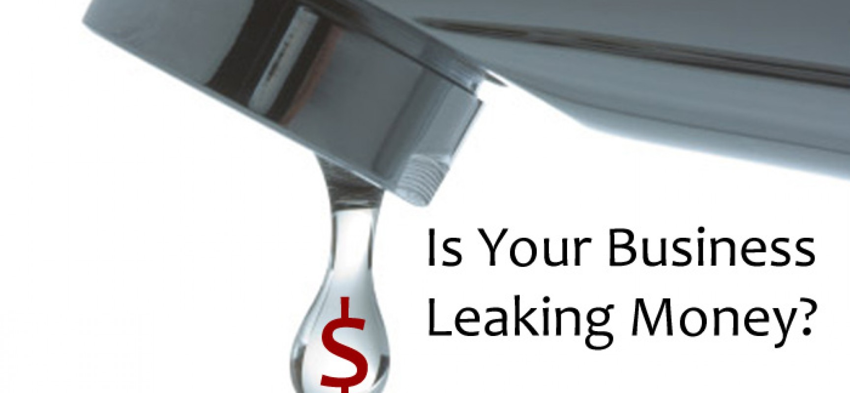 Just like your water bill when the toilet keeps running, little money leaks can add up before you know it. If you feel that sometimes cash slips through your fingers or that you are not putting away enough for a rainy day, this may be why. Try these quick, simple steps right now to avoid money leaks in order to block those financial holes and keep yourself from slipping underwater. For starters, begin with downloading online statements from credit cards, such as American Express or Chase Visa, into a spreadsheet. In your online statement, find the option for "download activity" or "export information." You can download directly into a program like Quicken – or as a CSV (comma separated values) file that will load into most spreadsheet programs, such as Excel. This way you can get the big picture for a month or a year to understand what you are spending by categories such as gas, restaurants, clothes or merchants. Start cutting out on things that you are not using. There will be number of things that you may not be using like newspaper, that now you prefer reading on I Pad or a healthy club membership that you are rearely visiting because of your busy schedule and so on. Cutting on unnecessary spending will set out a right budget for you. Pay yourself first is standard advice, meaning that you should save 10% to 15% of your salary, and it’s easiest if it comes off the top, before you ever see the money. Arrange an automatic payment to your 401(k), IRA or investment account, just as you might for other important recurring costs like your rent, car payment and health insurance. At the same time, see if you can set up the rewards plan on your credit card to feed directly into your savings account rather than your checking account. See if you can manage some savings on your mobile phone plan. Messaging, video chatting and even calling can usually all be done over WiFi. You can sign up with Skype, for instance. Also, while you’re looking at your internet life, think that do you need cable TV? Go through your spreadsheet again. Find things that are luxurious but not necessary or things that are nothing but money drain like having a take out every other night than home cooking. All you have to do is cut back on some unnecessary shedding and transferring that amount to your savings.

