Is mutual fund a safe investment?
Categories | Economy
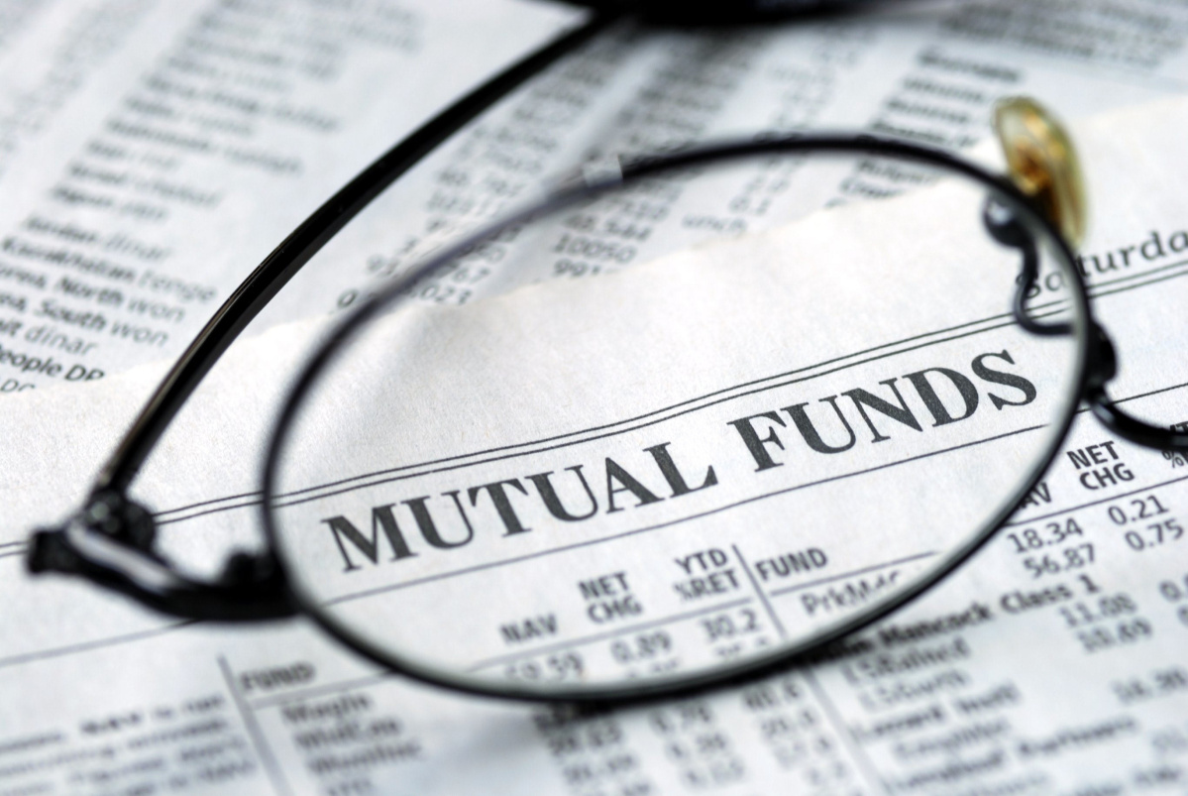 When you invest your money into something you expect to make the most on its return without taking much risk. And that is the one reason why many people prefer going for mutual fund. In a recent survey conducted by the Investment Company Fact Book, 2014, the US mutual fund industry is the largest in the world. It has $15 trillion assets. So wondering why people go for mutual fund after all but before that know what exactly is mutual fund. So basically a mutual fund is an investment which is made up of funds that is collected from many investors for the purpose of investing in stocks, bonds, and other securities. These funds are managed by money managers. These money managers invest the fund's capital and then try to produce some income for the fund's investors. See, there are many people who want to invest money somewhere but don't know for sure where. So these people end up investing money in mutual fund because they know that mutual fund invested money will be rightfully watched by the portfolio manager. These portfolio managers know where and when to invest your money in the fund. They also make a good decision of buying or selling the investments. While some mutual funds require only $500 to start investing so this way you can make the investing accessible to investors who are just starting. The fund manager will invest the mutual fund money in various securities like bonds, stocks and other securities. They also invest in a variety of companies and industries. Mutual funds are very attractive. They can easily grab your attention as they are affordable and liquid in nature. The mutual fund cannot manage your money for free and they need to charge the counsel. Remember that there are many good mutual funds that do not charge sales load while there are some who charge a load usually up to 5% to access the fund. There are also surrender penalties that forces you to leave your money in it's fund. This can continue for years like about eight years and could cost about 8% of the value of your investment. So do not be alarmed of mutual fund anymore. In fact it can be a good option for investors, either small or large.

